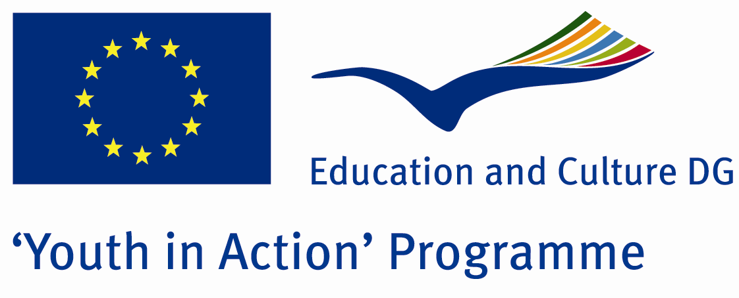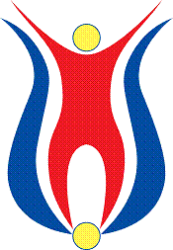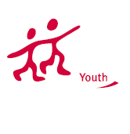

Action 1.1
Project Summary;
A lot of beauty in our world is devastated by aimlessly.There are many ways to stop this damage.Well, we are testing how much of these roads? What is recycling?Why should we reforest our world that living in it?What is the harm of pollution in the sea to us?Where are lions, crocodiles, eagles? we know how many of these problems and much of what we apply in our daily lives?The aim of our project, to teach our nature preserve, to maintain green .. And so let's all together on a common denominator.
Project Title; The Nature is our Mother
Date and Venue ; 02-09 March 2012
Place: Balıkesir

Target Group ; Municipalities, City Councils and Non-Governmental organizations,
youth groups,culture and art groups,e.t.c

Participants ; 5 people from each country (over 18 -25 ). Totally 8 countries.

Conditions ; Accommodation, board and programme costs will be financed through European Commission Youth in Action Programme . Travel costs will be reimbursed in 70% (APEX Tarrifs). Organizations from all 27 EU member countries plus Liechtenstein , Norway and Iceland are eligible to take part.

Working language: English

Organisator group: Group Doğa

How to apply: If you are interested, please send your Part III forms to
by e-mail please (in word file). Scan Part3 format is enough for application.(Fulfilled Part III which you can find in the attachment, of course signed and stamped) ..

Contact e-mail: groupdoga@gmail.com

